**PHASE-4 FIRST PROJECT**

**OUTPUT SCREENSHOTS:**

When the user clicks the HOME button, it will show home page as below

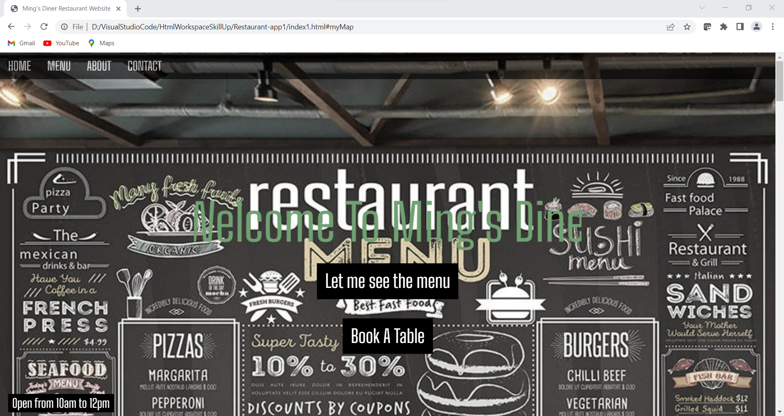

When the user clicks the MENU button or LET ME SEE THE MENU button, it will show Menu page as below

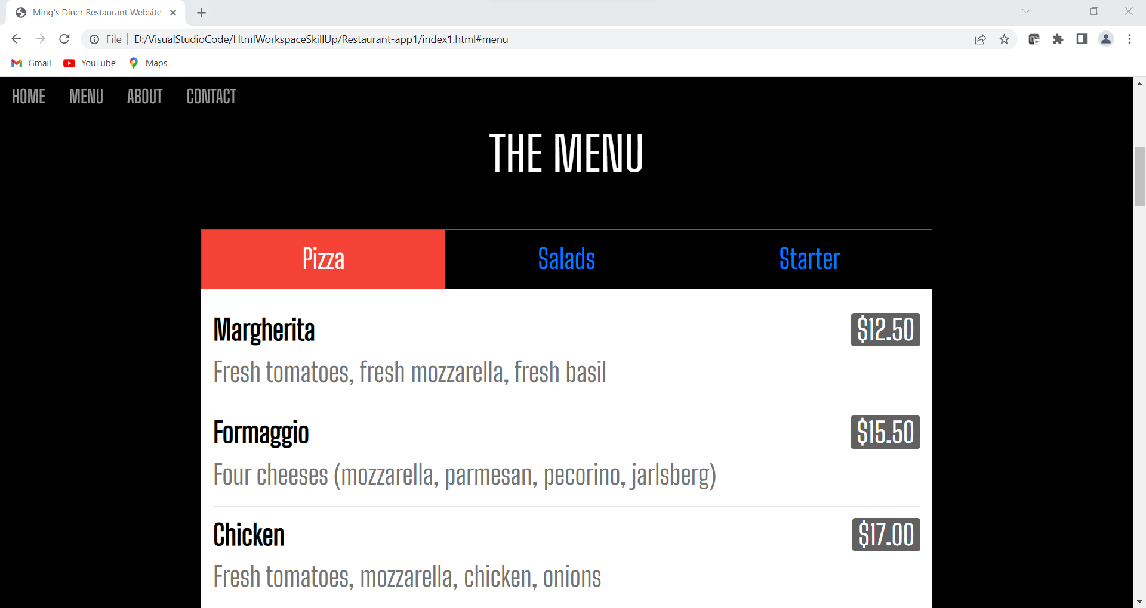

When the user clicks the ABOUT button, it will show About page as below

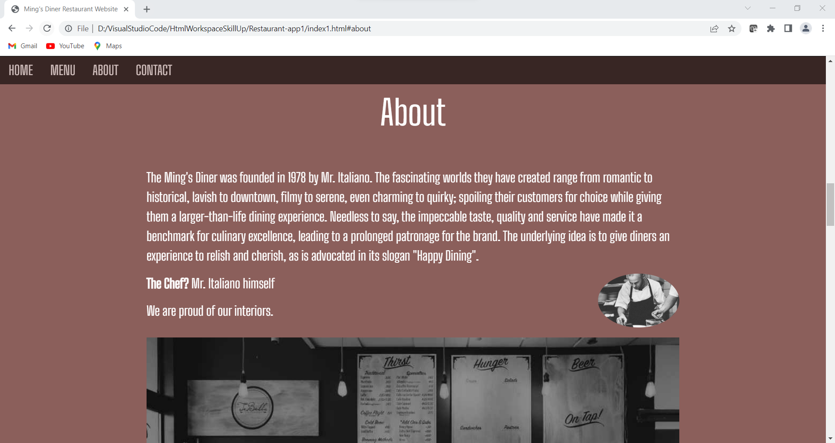

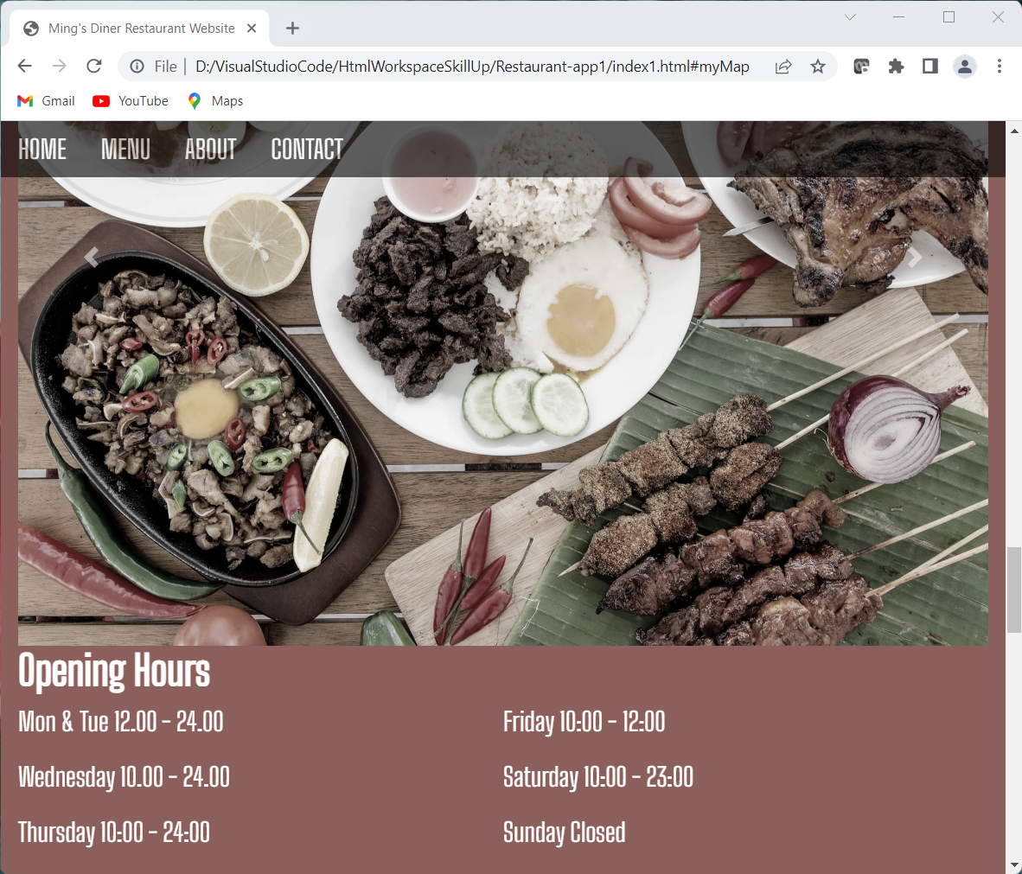

When the user clicks the CONTACT button or BOOK A TABLE button, it will show Contact page as below

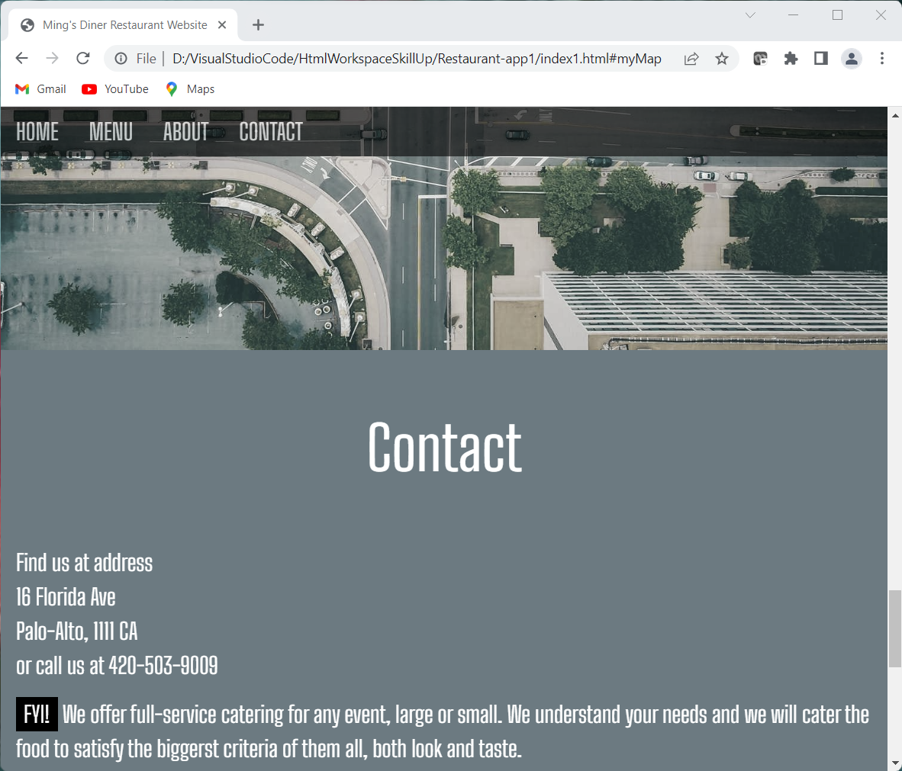

When the user clicks the BOOK A TABLE button, it will show Contact page as below

A contact form for users to contact the restaurant

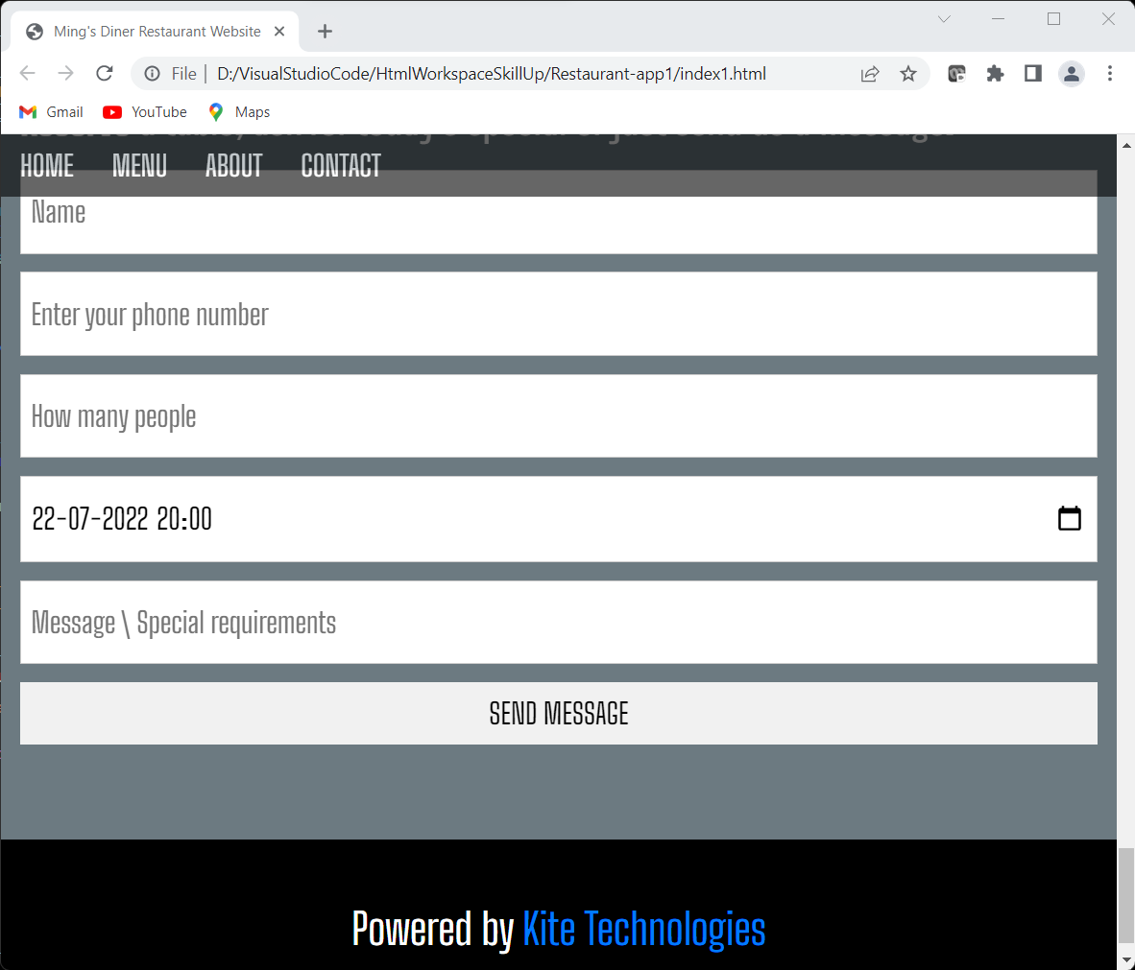

The images used in the creation of the website are as below

HOME PAGE

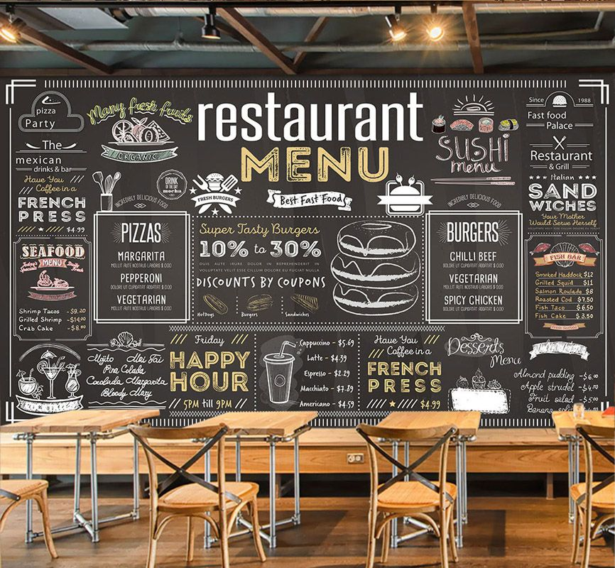

ABOUT PAGE

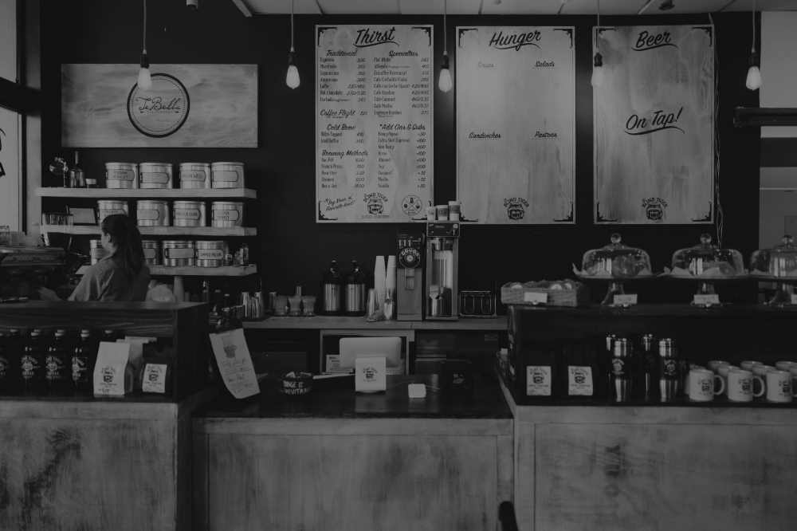

ABOUT CHEF

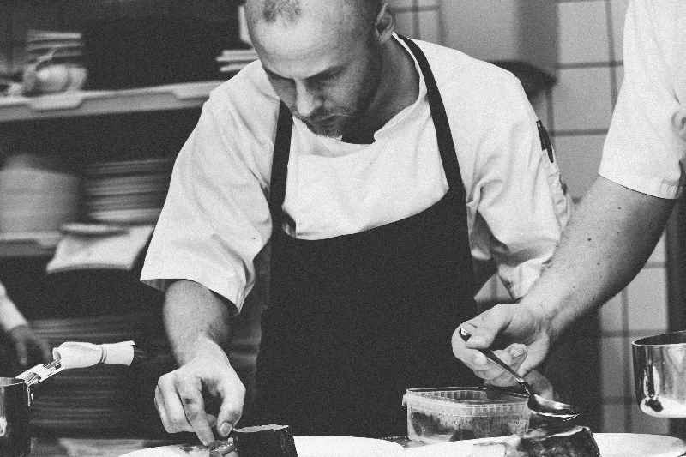

CAROSEL SECTION

FOOD 1

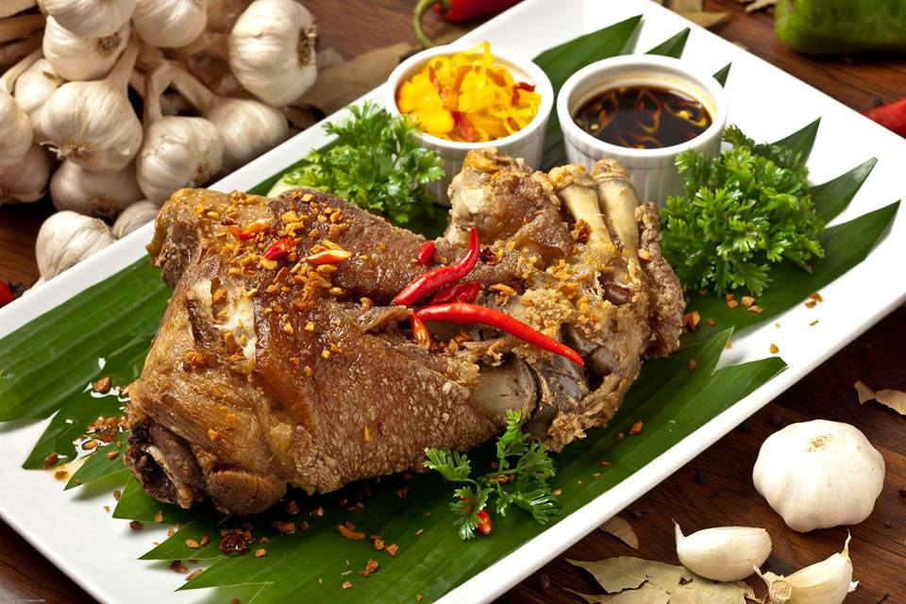

FOOD 2

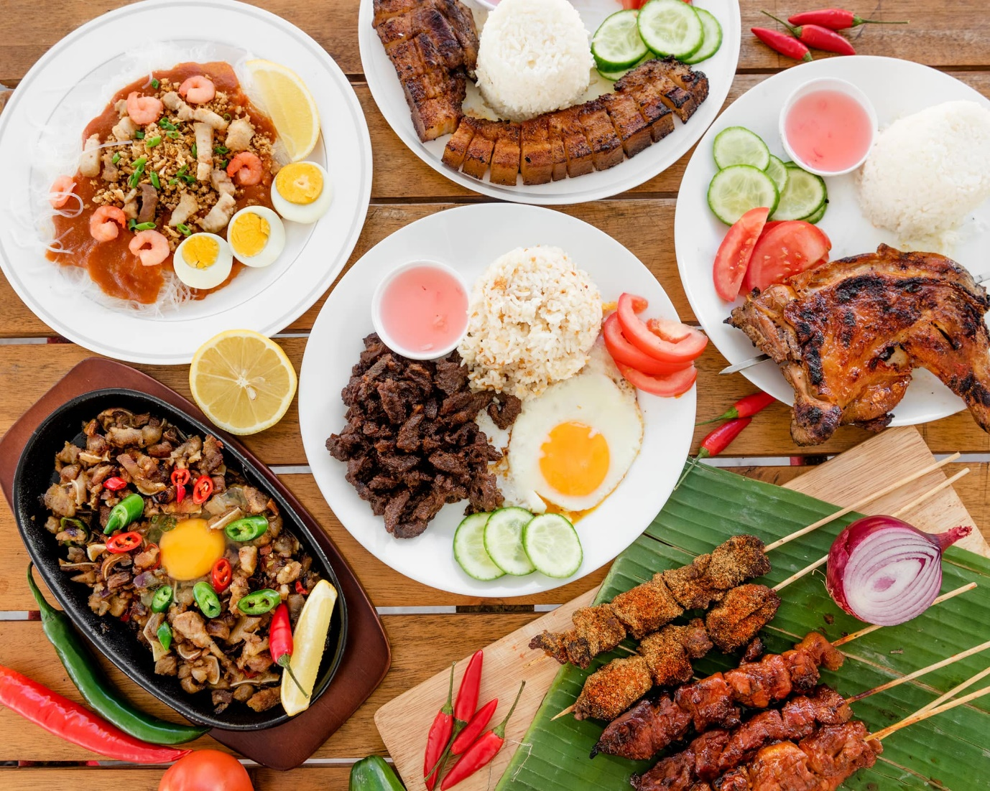

FOOD 3

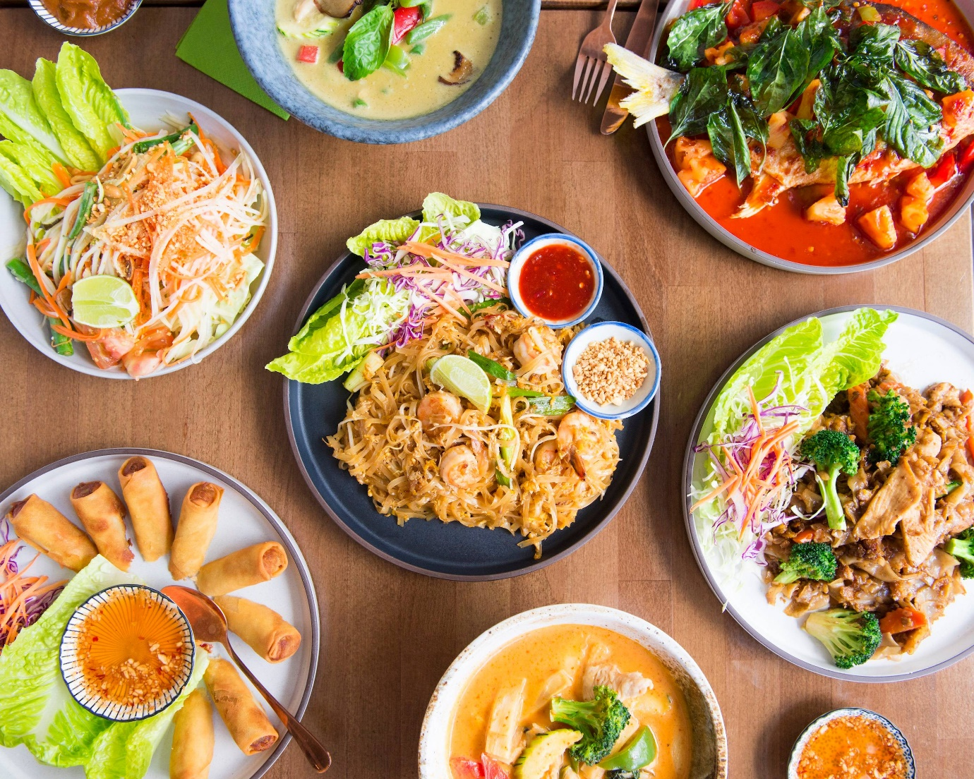

TYPES OF PIZZAS

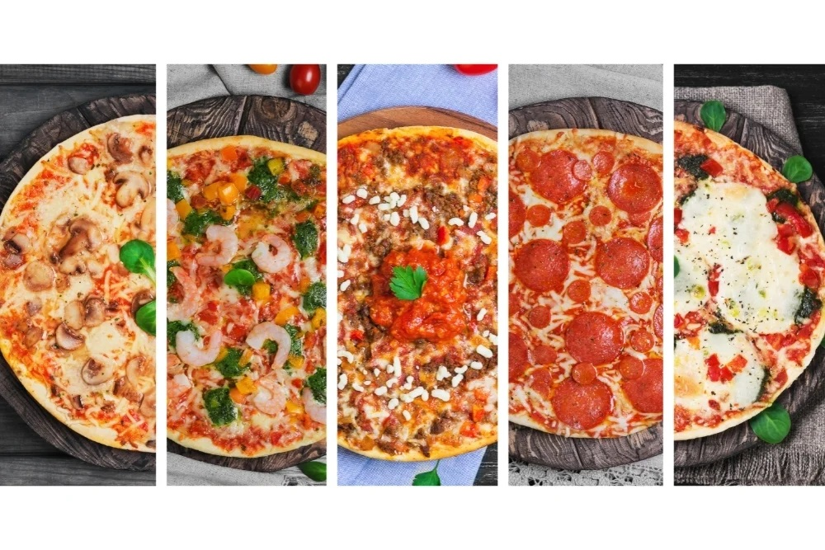

CONTACT PAGE

MAP

